Chapter 3, Solution 69

For the circuit in Fig. 3.113, write the node voltage equations by inspection.

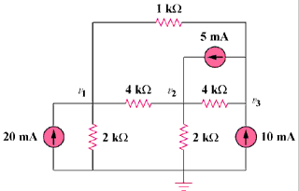

Figure 3.113
For Prob. 3.69.

Solution

Assume that all conductances are in mS, all currents are in mA, and all voltages are in volts.

G₁₁ = (1/2) + (1/4) + (1/1) = 1.75, G₂₂ = (1/4) + (1/4) + (1/2) = 1,
G₃₃ = (1/1) + (1/4) = 1.25, G₁₂ = -1/4 = -0.25, G₁₃ = -1/1 = -1,
G₂₁ = -0.25, G₂₃ = -1/4 = -0.25, G₃₁ = -1, G₃₂ = -0.25

i₁ = 20, i₂ = 5, and i₃ = 10 – 5 = 5

The node-voltage equations are:

